**Analysis of Social Media Usage Patterns**

Name: Shravani Mukkarigaris

Kaggle database link: <https://www.kaggle.com/datasets/imyjoshua/average-time-spent-by-a-user-on-social-media>  
ipynb link:<https://github.com/Sweety-gif-sys/Statistics-and-Trends-/blob/main/Socialmedia_Usage_stat%26trends.ipynb>

**Introduction**

Social media platforms have become an integral part of daily life, which affects people's interaction, sharing and access to information. To make an informed decision, knowing the trends and patterns hidden behind is important. This work examines with the help of a Kaggle dataset based on details related to demographics, usage time, and financial information. This analysis will help to gain insights into the most preferred social media platform, behavioral trends, and the influencing factors. The results contribute to improving social media marketing by understanding the behavioural trends of users.

**Dataset**

The dataset was sourced from the Kaggle depositories, an open-sourced website. This dataset has nearly 1000 data and 12 attributes. This dataset gives insights into how much people spend on various social media platforms on average. This dataset contains details on the age of people, time spent, which platform, user location, profession, income, and financial indicators. This dataset can be used to analyze user behaviour and their preferences by identifying the patterns and trends. This dataset can also be used in various fields like marketing analytics or social media impact research. For researchers who have been seeking to understand user behaviour and evaluate the effectiveness of social media marketing strategies, this would be a perfect choice.

**Bar Chart for the Comparative Analysis of Social Media Usage by Gender**

The bar chart below compares the usage of social media platforms based on gender. As per analysis, the male been using the social media more than female and non-binary.

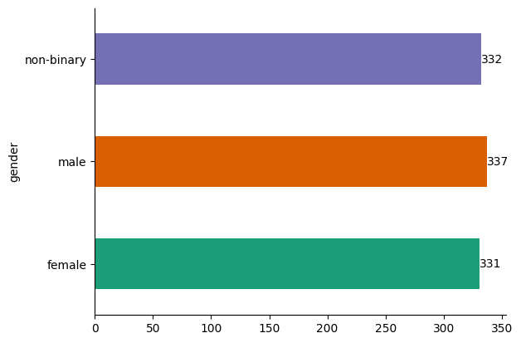

**Bar Chart for the Distribution of Social Media Usage Time**

The charts below visualize the distribution of time spent on social media platforms. The visualization shows that the highest frequency is 5, followed by 4. It shows that most users spend 4-5 hours a day on social media. Other common times spent on social media are 2, 9, 6, and 8 hours. This shows that people are commonly spending more time consistently on social media.

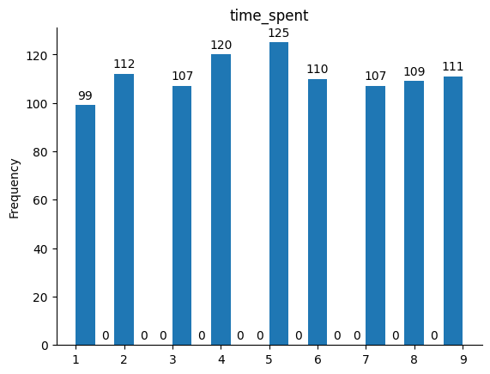

**Bar Chart for Social Media Engagement Across Gender and Platforms**

The below charts show the gender and platform distribution. It shows the comparison of social media usage with different platforms such as Instagram, YouTube, and Facebook. As per analysis, Instagram seems to be a highly used platform, YouTube shows a balanced engagement, and Facebook has the lowest count comparatively. The findings state that the social media platform Instagram is the dominant in user’s engagement.

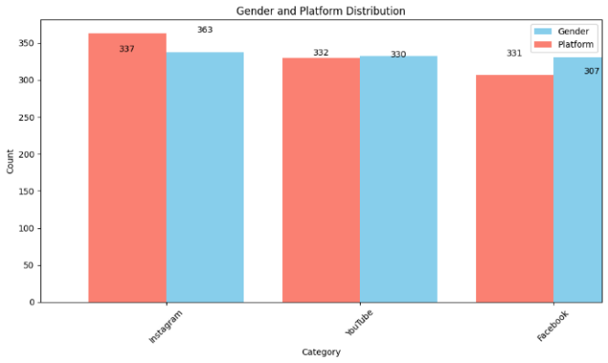

**Violin Plots for Age Distribution Across Social Media Platforms**

The below violin plot shows the distribution of age across different social media platforms. Most of the young people from their 20s to 30s are mainly using Instagram. Facebook is used by older people, while YouTube is used by all categories of people from teenagers to adults. The insights show that Instagram is used by younger people, Facebook by older users, and YouTube by all categories.

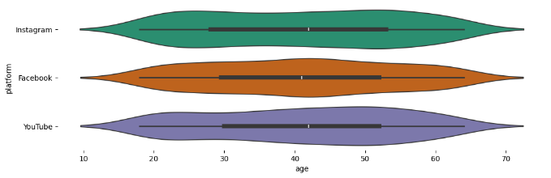

**Scatter Plots for Age vs Time Spent on Social Media**

The below scatter plot shows the image visualizing the relationship between age and time spent on social media platforms. This shows that people from different age groups have been spending the same amount of time on social media. Nevertheless, the younger people between 20 to 30 years of age seem to be spending some more time on these platforms comparatively. This shows that younger people tend to use social media platforms than older ones.

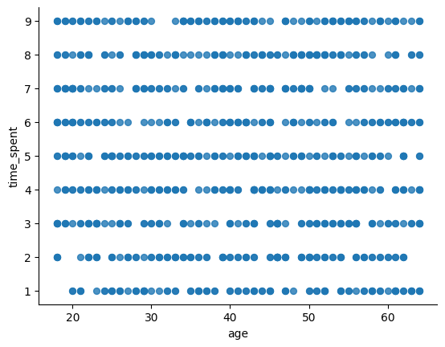

**Correlation Matrix**

The below correlation matrix shows the relationship between different factors like age, time spent, and income. Most of the factors are near zero, which shows that there is a weak relationship between those variables. The insights state that many variables in the dataset are mostly independent.

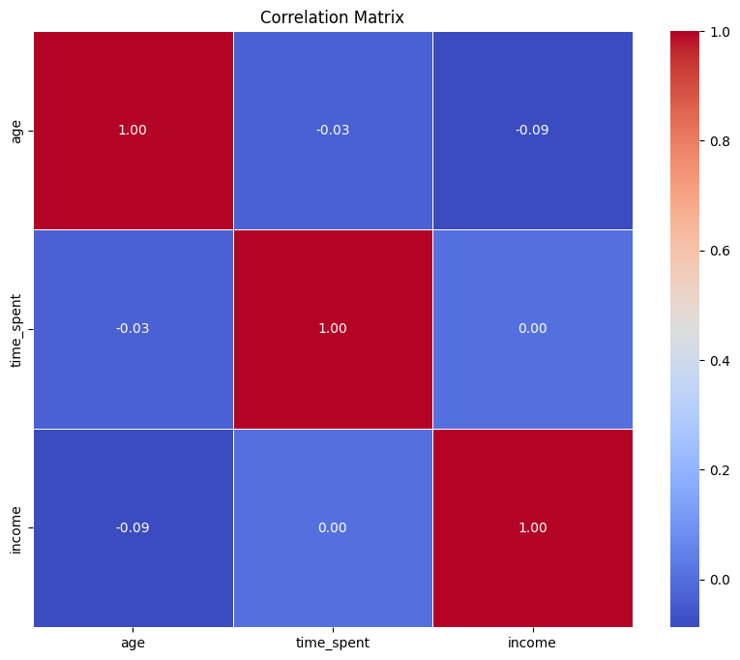

**Conclusion**

The analysis on this states that young users prefer using Instagram, older users are into Facebook, and the platform YouTube been used by everyone despite the age. All the people seem to use the social media platforms at similar times, but younger generation seems to consume a bit more time. This analysis will help marketers and researchers to gain better insights on digital behavior.